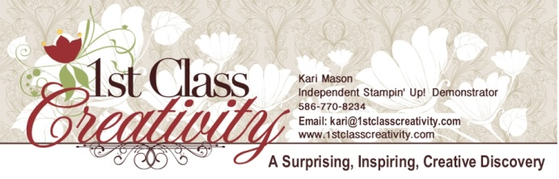

Witching Décor Project Kit Supply List

Kari Mason, August 2015
www.1stclasscreativity.com
This list is EVERYTHING you will need to create the Witching Décor Project Kit featured in the video and in the Holiday 2015 Stampin’ Up! Catalog on Page 7.
- Witching Décor Project Kit - $22.00
  - Item#140969
- Witches’ Night – photopolymer stamps (pg. 7 of Holiday Catalog)
  - Item#139708
- Clear Blocks needed for Witches’ Night:
  - Block C – Item#118486 $7.00 (2” x 2 ¼”)
  - Block E – Item #118484 $12.00 (3 7/16” x 4 7/16”)
  - Block F – Item #118483 $17.00 (4 7/8” x 6”)
  - Block H- Item #118490 $8.50 (4-7/16” x 1 5/8”)
- Haunt Ya Later Stamp Set (as featured in video)
  - Item#139696 $25 (wood)
  - Item# 139699 $18 (clear)
- Howl-o-ween Treat Stamp Set (as featured in video)
  - Item #139687 $28.00 (wood)
  - Item #139690 $20.00 (clear)
- Clear Blocks needed for Clear Stamps Only - Haunt Ya Later & Howl-o-ween Treat:
  - Block B – Item#117147 $6.00 (1 5/8” x 1 15/16”)
  - Block C - Item#118486 $7.00 (2” x 2 ¼”)
  - Block D – Item#118485 $8.50 (2 7/8” x 2 11/16”)
  - Block G – Item #118489 $4.50 (2 ½ “ x ¾”)
- Bone Folder
  - Item#102300 $7.00
- Tweezers – Found at beauty or grocery store
- Ink:
  - Soft Suede Classic Ink
    - Item#126978 $6.50
- Grid Paper:
  - Item#130149 $10.00
- Scissors:
  - Paper Snips
    - Item#103579 $10.00

- Stampin’ Write Markers:
  - Witches Hair – Cajun Craze (Regals Collection Item#131262 $29.00)
  - Witches Eyes – Smoky Slate Item#131898 $3.50
  - Witches Eyes – Soft Sky (Subtles Collection Item#131263 $29.00)
  - Witches Clothing – Blackberry Bliss (In-Color 2014-2016 Item#133654 $15.00)
  - Witches Accessories and Shoes – Tangelo Twist (In-Color 2014-2016 Item#133654 $15.00)
  - Witches Skin – Pear Pizzaz (Subtles Collection Item#131263 $29.00)
  - Frog – Wild Wasabi (Subtles Collection Item#131263 $29.00)
  - Necklace - Basic Black Item#100082 $3.50
- Adhesive:
  - Fine-Tip Glue Pen
    - Item #138309 $7.00
  - Stampin’ Dimensionals
    - Item#104430 $4.00
  - Tear & Tape Adhesive
    - Item#138995 $7.00
  - Multipurpose Liquid Glue
    - Item# 110755 $4.00
Look for some more videos and pdf’s from 1st Class Creativity –
subscribe to our YouTube Channel

Order Stampin’ Up! ® Supplies for creating this project
In my Online Store 24/7 at www.1stclasscreativity.com
(This will take you to my Stampin’ Up! store)

Kari Mason, Creative Coach & Owner 1st Class Creativity
Independent Stampin’ Up! Demonstrator
PO BOX 779, Washington, MI 48094
586-770-8234 (text or call – text messages rates apply)
EMAIL: 1stclasscreativity@comcast.net
www.1stclasscreativity.com

Find us on Facebook, Pinterest, Twitter, and You Tube

Tutorial © Kari Mason 2015, 1stclasscreativity, All rights reserved. All Images @Stampin’ Up! ®

