KRAFT GIFT BAG TUTORIAL

Tutorial © Kari Mason, November 2013
www.1stclasscreativity.com

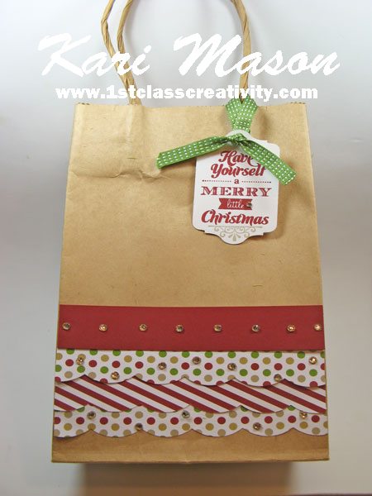

A gift doesn’t always need to be wrapped in a box and this is where a nicely decorated bag comes in! Surprise your friends by decorating it yourself.

Tutorial ©Kari Mason 2013, 1st Class Creativity, All Rights Reserved, All Images Stampin’ Up!®

SUPPLIES:
STAMPS: Merry Little Christmas 131826 wood-mount, 131829 clear-mount
INK: Gumball Green 126861, Cherry Cobbler 126966, Crumb Cake 126975
CARDSTOCK: Whisper White 100730; Cherry Cobbler 119685; Season of Style Designer Series Paper Stack 132181
ACCESSORIES: 113439 Big Shot; Chalk Talk Framelits 129983; Large Scallop Edgelit 127019; Basic Rhinestones 119246; Small Kraft Bag, Gumball Green 3/8” Stitched Ribbon 126848
DIMENSIONS:

- Cut three 5-1/4” strips from the Season of Style DESIGNER SERIES PAPER stack. (Same sheet was used for all 3 strips with the reverse side on the second strip).
- Cut a 5-1/4” x 1” Cherry Cobbler cardstock
INSTRUCTIONS:
- Using the Large Scallop Edgelit, die cut Season of Style DESIGNER SERIES PAPER stack.
- Adhere the strips starting about 1/2" from the bottom of the bag (a 8-1/2” x 5-1/4” bag was used for this project)
- Adhere Cherry Cobbler above the DESIGNER SERIES PAPER strips.
- Place rhinestones on 2 DESIGNER SERIES PAPER strips and on Cherry Cobbler cardstock, making sure the rhinestones are not all lined up underneath each other.
- Stamp sentiment with Cherry Cobbler ink and scroll with Crumb Cake ink;
- Using the Chalk Talk Framelits, die cut sentiment
- Take the 13” Gumball Green Stitched Ribbon and place over one of the handles then thread through the hole on the tag and make a knot. Trim off ends.
- Place a smaller rhinestone next to the word ‘little’.
- Now you have a decorated bag ready to be filled with your gift.

Order Stampin’ Up!® Supplies for creating this project
in my Online Store 24/7 at www.1stclasscreativity.com
(this will take you to my Stampin’ Up! store)

Kari Mason, Creative Coach & Owner 1st Class Creativity
Independent Stampin’ Up! Demonstrator
PO BOX 779, Washington, MI 48094
586-770-8234 (text or call – text messages rates apply)
EMAIL: 1stclasscreativity@comcast.net
www.1stclasscreativity.com

Find us on Facebook, Pinterest, Twitter, and You Tube

Tutorial © Kari Mason 2013, 1stclasscreativity, All rights reserved. All Images @Stampin’ Up!®

