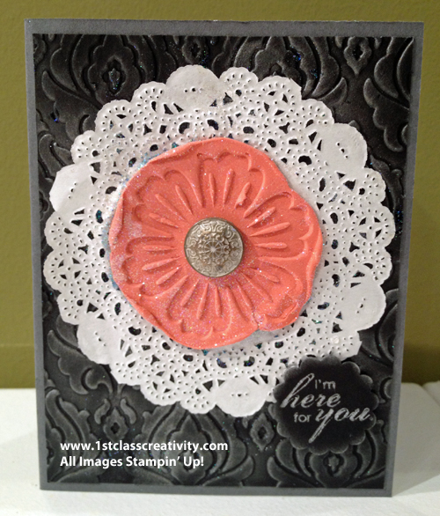
SUPPLY LIST
- Stamp Set:
  - Mixed Bunch (wood-128442 clear-125537)
  - Blooming with Kindness Stamp Set (wood - 131961 clear - 126422)
- Ink:
  - Silver Metallic Encore Pad (132142)
- Card Stock:
  - Basic Gray (121044) cut to 5 1/2 x 4 1/4
  - Basic Black (121045) cut to 5 1/4 x 4.
- Accessories:
  - Simply Pressed Clay (130685)
  - Calypso Coral Re-inker (122934)
  - Dazzling Diamonds Glitter (102023)
  - Beautifully Baroque Embossing Folder (130917)
  - Big Shot. (113439)
  - Sponge Dauber (102892 set of 12)
  - 7/8" Scallop Circle (129404),
  - Tea Lace Paper Doilies (129399)
  - Vintage Brad (117273) pick out one of the two 11/16" brads
  - Craft Scissors (108360)
  - Paper Piercing Tool (126189)
  - Crystal Effects (101055)
  - Stampin’ Dimensionals®
  - Snail adhesive® (104332)
  - Paper Plate

